When we tried to get data from the source website it was giving us xls files we needed our data to be in csv to use and manipulate data in pandas so we we had to convert the file types.

We had to clean data but the dataset was too large, so we broke it into batches and ran those separately . we also used scripts for automation since all the files followed the same pattern for cleaning and creating new cleaned csv files

Look back days were uncertain, so we were thinking it is the time for the crop to grow from seed to tree in certain cases like bajra it works but in cases of coconut it takes too long almost 12-80 years so we settled on taking the harvest days, so coconut produces

In a year so we took that.

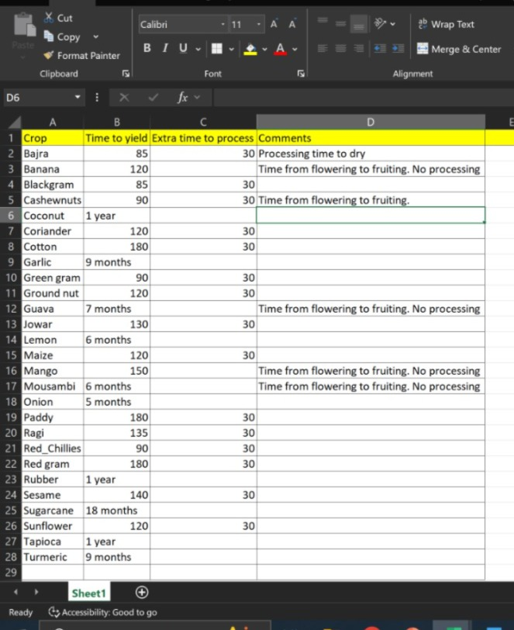

Our api call Is timing out while getting weather data , it could not handle too many calls. Api is also blocking us error code 429 due to api calls from one network so we are switching the network and for too many calls we are adding sleep function.